**Bank Account - Interface**

ICUC is a financial institution that provides facilities such as current account and savings account to its customers. To add to its facilities they have come up with the locker that is chargeable. Since it is a new facility introduced, many customers have approached them to enquire about this facility.

To make the banking service effective, ICUC plans to automate the calculation of the locker maintenance charges based on the various account types and the duration.(in years).

Help them by creating a Java application that caters to their requirement.

**Requirement 1: Maintenance Charge Calculation**

The customer needs to provide information like account type, customer name,

account number, balance and number of years to calculate the maintenance charge.

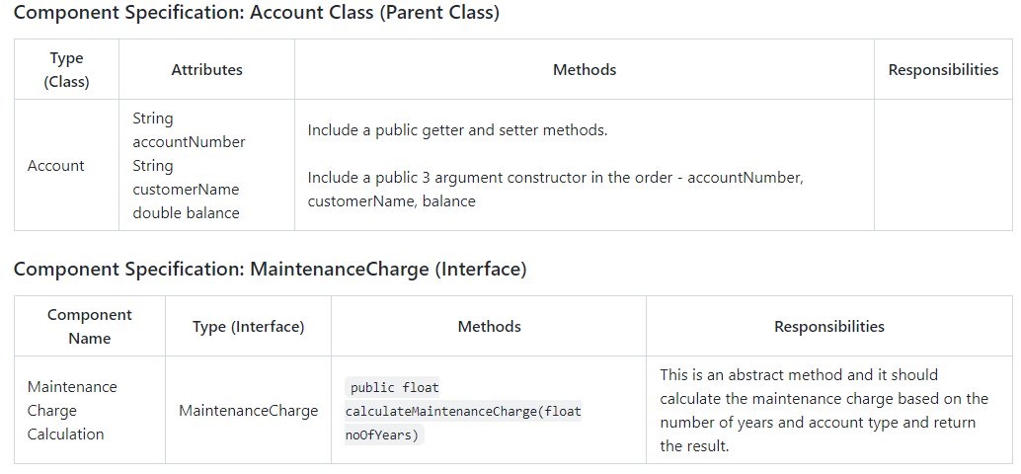

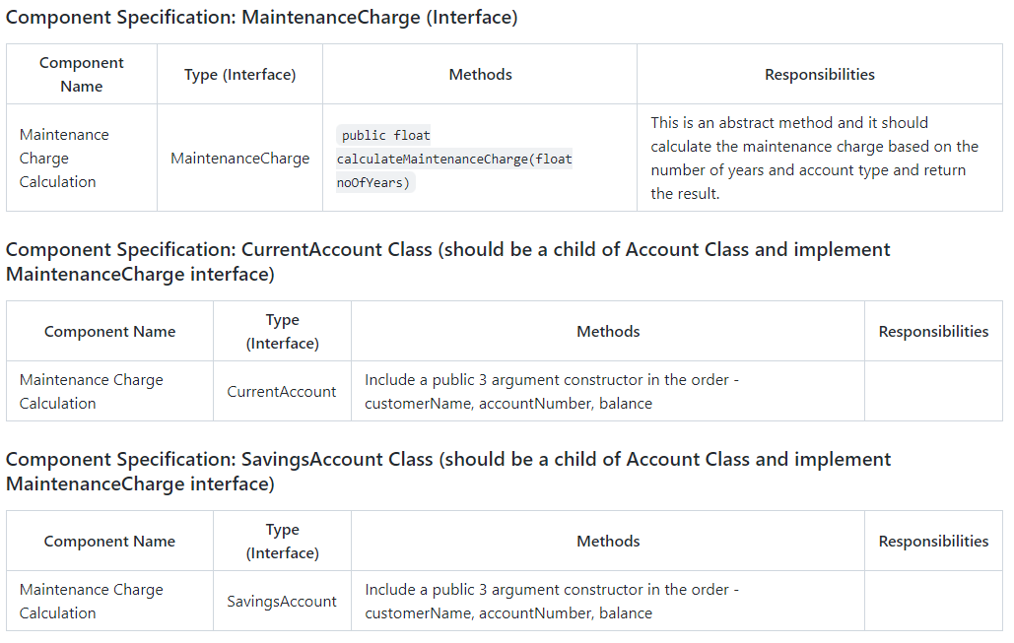

Both the child classes CurrentAccount and SavingsAccount should override the calculateMaintenanceCharge(float noOfYears) method.

The calculateMaintenanceCharge(float noOfYears) should return the maintenance charge based on the number of years and the account type.

The Maintenance Charge needs to be calculated as shown below:

For Savings Account: Maintenance Charge = (m * n) + 50

For Current Account: Maintenance Charge = (m * n) + 200

Here, m is the base charge per year and n is the number of years. The base charge m, is Rs.50 for a Savings account and Rs.100 for a Current account. The number of years n, should be taken as input from the user as noOfYears.

Implement the calculateMaintenanceCharge method in the CurrentAccount and the SavingsAccount class based on the above assumption.

All class, interface and methods need to be public and attributes need to be private.

Write a class UserInterface with the main method to test the above functionality.

Input 1:

1. Savings Account

2. Current Account

Enter your choice:

2

Enter the Account number

123456789

Enter the Customer Name

Rohit

Enter the Balance amount

5000

Enter the number of years

2

Output 1:

Customer Name Rohit

Account Number 123456789

Account Balance 5000.0

Maintenance Charge for Current Account is Rs 400.0

Input 2:

1. Current Account

2. Savings Account

Enter your choice:

1

Enter the Account number

123456798

Enter the Customer Name

Rohini

Enter the Balance amount

5000

Enter the number of years

2

Output 2:

Customer Name Rohini

Account Number 123456798

Account Balance 5000.0

Maintenance Charge for Savings Account is Rs 150.0